# **When I Grow Up...**

**Zoe's avatar**

[Zoe](https://substack.com/@zoeffc)

Sep 13, 2024

Share

Hello!

I have a funny story to share to kick off this week’s note:

During my final week at my last job, my old boss attended a couple of formal meetings. One meeting was with various university leaders, her bosses, and the other was one where she herself was a leader. As an icebreaker in both meetings, they went around the rooms and asked everyone what they wanted to be when they grew up. It sounds like most of the answers were fairly tame like a firefighter or an astronaut. My boss though? She proudly proclaimed to both rooms that day that when she was little, she had wanted to be a hooker. This was funny because she, of course, had no idea what a hooker was. How it came to be that she wanted to be something she did not understand, I am still unsure.

While you would have to twist my arm to convince me to tell a room of my higher-ups that I wanted to be a hooker when I grew up, Little Zoe did have ambitions of her own. This week, I want to write about the various aspirations that I had/have for my future, and invite you to consider your own.

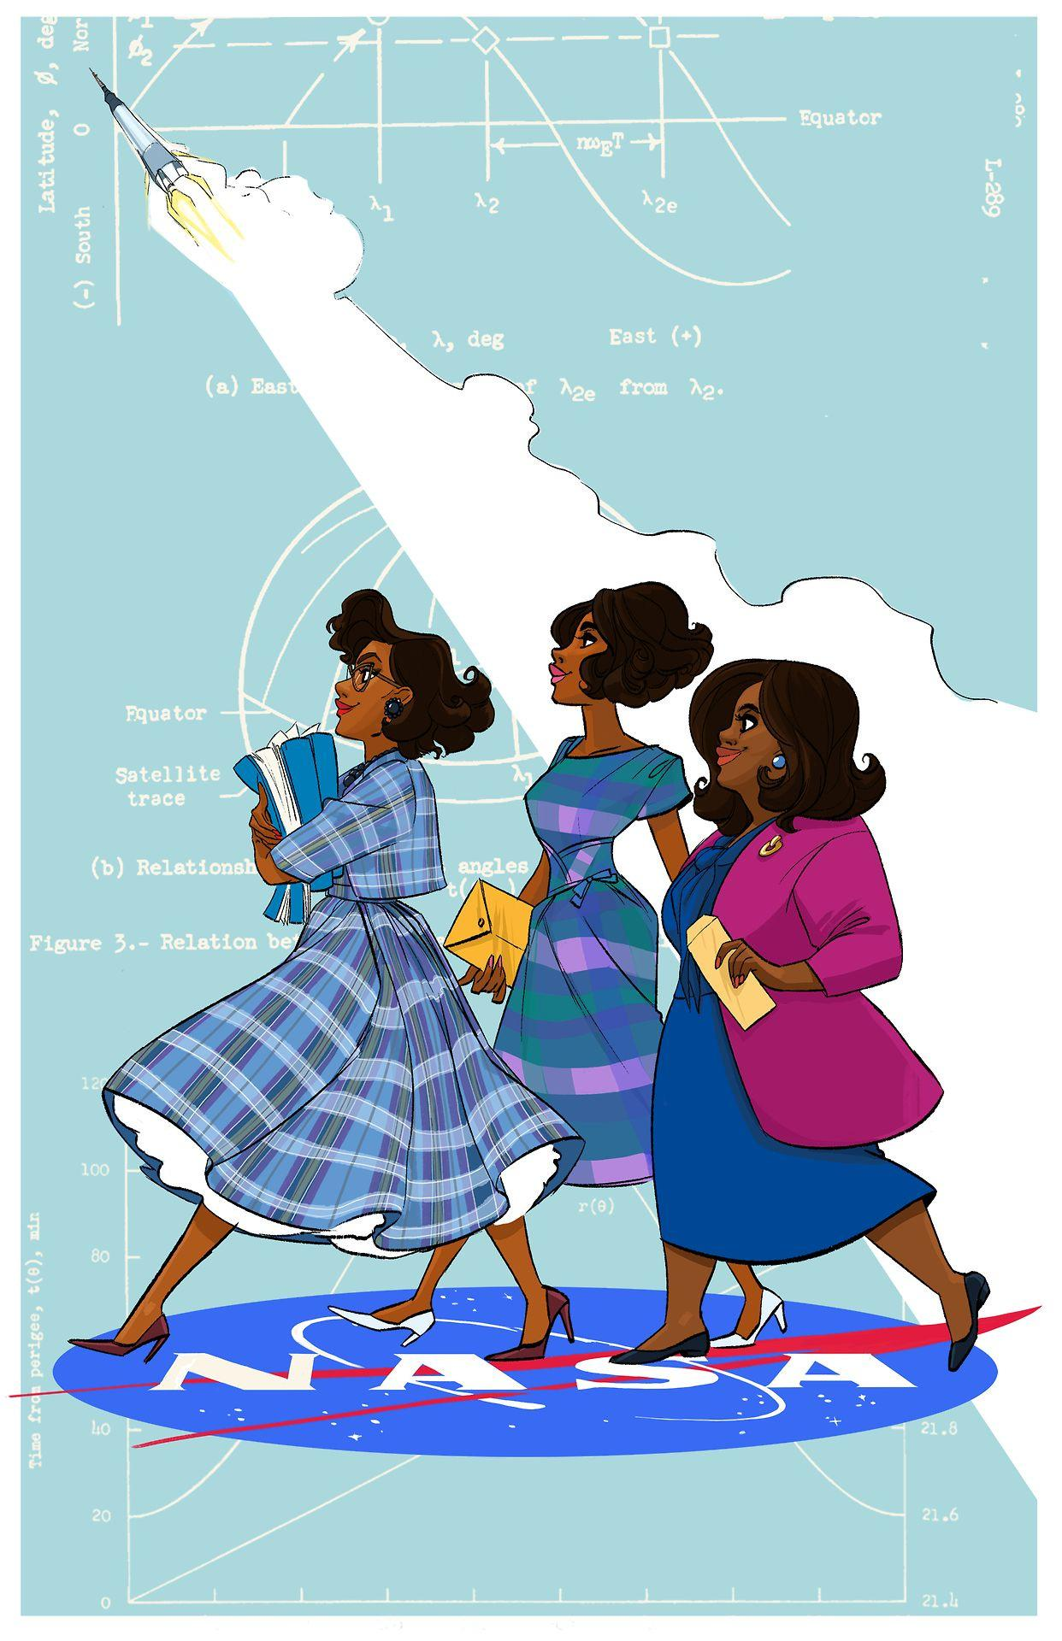

*The women of Hidden Figures — artist unknown*

First some housekeeping:

📫 If a friend forwarded you this newsletter (then you have some really cool friends), and you may want to consider joining us here for regular updates.

[Subscribe](https://femme-futures.beehiiv.com/subscribe)

🧲 Got some thoughts you want to share? Join us on Discord to chat all things newsletter and corporate life.

[Discord](https://discord.gg/vbaXxrq8?utm_source=femme-futures.beehiiv.com&utm_medium=referral&utm_campaign=when-i-grow-up)

You can find all archived newsletters at the online site, if you ever want to go back or if you just feel like perusing.

[Check out the website](https://femme-futures.beehiiv.com/)

In an icebreaker, if you asked me what me wanted to be when I grew up, I would probably say “a gymnast” or “a ballerina”. Those things are true enough, but they are also safe answers. They don’t feel particularly important to who I am today. Sure, ballet played a massive role in making me who I am today. That is a conversation for another week.

Here are some other, better, truer answers:

“An Inventor”

I grew up in a college town that was filled with bookshops. I have a distinct memory of sitting on the floor in one such used bookshop, hunched over a picture book about a little boy who invented a superior car. (If I manage to remember the book’s title, I’ll throw that detail on the discord.) I still think about this book a lot actually. I loved that the little boy made adjustments that, while impossible based on the current science, would make life a little better. For example, he made the exterior squishy! The rationale: no dents and safer crashes.

It was around this time that I had an obsession with taking apart my family’s old cream-colored, wall-mounted landline telephone so that I could see the circuitry and try to put it back together. I would build fairy houses and car garages out of sticks and leaves and I would bead my bike tires with colorful straws. I wanted to know how things work and how I could make them better.

“An Entrepreneur”

I wonder if anyone sitting in those rooms with my boss had said that they wanted to be an entrepreneur. I wouldn’t be surprised if anyone had. It’s pretty stock-standard. I know that today, when kids say that they want to be “influencers”, we cringe, but that’s a type of entrepreneur. When I was little, it would have been a start-up entrepreneur á la Mark Zuckerberg, Bill Gates, or Steve Jobs. In middle school, I read biographies of tech entrepreneurs. It was cool to imagine an idea coming to life so much that full industries changed to accommodate it. I think that being a bit cringe is what defines being an entrepreneur. You cannot tell me that no one cringed at the story of Zuckerberg founding Facebook to get dates.

I am not good at being the target of so-called “cringe”, but I want to be better at it. Being vulnerable and failing publicly are terrifying, but they are also the strengths of world-changers.

“A Writer”

In elementary school, my friend and I decided one day to play in the backyard with fairy barbies and a digital camera. We made our own picture book, detailing the backyard adventures of Fairy Barbie. I think that it was that experience that started my itch for storytelling. I have spent years of my life puzzling through plot designs. I’ve started writing more novels than I can count, and every November since I was in eighth grade, I seriously consider participating in National Novel Writing Month (NaNoWriMo).

This aspiration made me the teacher’s pet in my English classes for most of my life, very nearly made me an English major in college, and led to my first job out of college as a grant writer. I think that it’s what led me to Femme Futures as well. I like language. I will get words and phrases stuck in my head, and can only understand the world through metaphor.

“Someone”

So who is the “someone” that I want to be? Every time that I was told the answer to that question lay in all of the answers to “what do you want to be when you grow up?”, I struggled.

One of the things about American culture today is that we expect everyone to “pursue their passions”. When we are deciding what to do after high school, we are told this. When we are picking a major, we are told this. When we are applying for our first jobs, we are told this. If we don’t know what our passions are, then we are told to find a job that holds social status either through financial gains or stereotype.

My default answer has been “a ballerina”. It was true at points. When I was in dance class every day after school for hours and then every weekend, I did it because I thought that one day I could be good enough to be “someone”. I could imagine auditioning for the New York City Ballet as several of my classmates would. But like I said before, “a ballerina” is my safe answer.

I think that even back then, a part of me knew that it wasn’t a viable dream, much like being an astronaut or someone with the power to teleport. Real desires, unrealistic path to accomplishment. “Ballerina” gave me an answer to the question though. It was sufficient for icebreakers, but in its whimsy, it kept others from really expecting it from me.

These other answers: a writer, an entrepreneur, an inventor, are much less safe because I want them much more. They are still grandiose, but somehow seem more achievable. (Winning the lottery is also technically achievable.) If I say these out loud, people will know what I care about and that is scary. People might hold me accountable. People might expect me to succeed. This is my push to myself to say “fuck it, I’ll try”.

Thank you for indulging my navel-gazing this week.

Warmly,

Zoe

**Stuff to Do:**

* **Journal** about what you want to be when you grow up. [You can also write it in an email and send it back to me, I would *love* to hear your thoughts.]
* **Meditate**. Take some deep breaths and ask yourself *“what lights me up?”*
* **Do it.** Do the thing that you have been itching to do, whether that is sending in a job application, writing a novel, or reaching out to an old or new friend. Just do it.

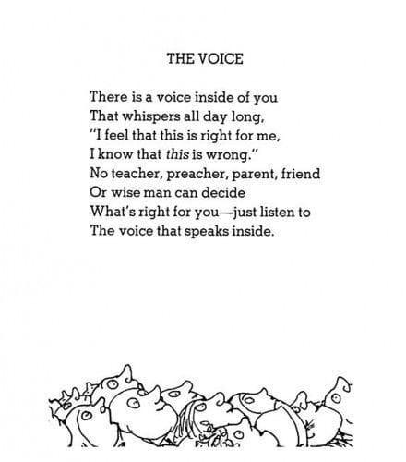

*Poem by Shel Silverstein*

**Femme Futures Cooperative Founding Principles**

💚**Mission**: The mission of Femme Futures is to create a community space for young professionals who identify as over-achievers and activists to generate collective success by providing resources and platforms to thrive in challenging workplace environments.

💙**Vision**: To contribute to a world where driven individuals are equipped with the tools, guidance, and connections to overcome systemic barriers, fully utilize their talents, and enact positive change in their organizations and communities.